Blogging Gold Profits

Steal My Blogging Secrets Of Making Hundreds Of Dollars Per Month!

Written By:

Thankyou for purchasing Blogging Gold Profits. In this report I am going to show people how to create must read blogs in any niche without having you lift a finger writing any of the content.
This report will show you how I create cash pulling blogs in almost any niche and then I am going to show you traffic generation methods.
I am going to show you how to create a kick ass blog, starting from scratch in any niche online. All this will be done without writing a single piece of content yourself.
I am sure that you have heard that you should start a blog based on what your interests are and things you are passionate about.
I am going to go out on a limb here and call bullshit! I am not saying that it can’t be done or that you shouldn’t give it a try if that is what you are looking to do. The problem with that model is that if you stop writing the whole thing comes crashing down.
You aren’t creating a business by going that route. You are BECOMING the business.
Let’s say that you create an amazing blog on a certain niche. It is getting tons of traffic and making you a lot of money. By that time you have spent a ton of time on creating the content and getting readers!
What do you do when you want to stop writing on that topic and move onto something else? That is were you get stuck because you are the PRODUCT!
You can’t really sell the site for what it’s worth because you will no longer be creating the content. The people who visit your blog regularly come to hear what you have to say. Take you out of the equation and the value of what you built takes a nose dive!
The key to building a kick ass blog is that it becomes a business/asset.
It should be able to be sell at any second for top dollar because you aren’t the sole content provider. I am not saying you can’t write for the blog but you can’t be the main content provider.
TechCrunch.com just sold for $30,000,000. That is roughly 36X monthly revenue that they were doing. The guy who started the site was the original author on the blog. Before he sold the site he was very rarely posting on the site. He recruited other people who were passionate about technology to write for his site and that turned TechCrunch into an asset that could be sold for big bucks.
Let’s compare that to someone like Gary Vaynerchuk who runs tv.winelibrary.com .
This guy has used social media to create a cash pumping website. He makes a ton of money based on his video blog.
The problem is that the business is based on him. HE IS THE BUSINESS! Trying to sell off winelibrary.com for its true value would be very hard because unless he continues to produce the content the site loses a ton of value.
That is why this report is going to show you how to leverage other peoples experience and writing abilities to build you a business. All that boils down to a simple equation:
CONTENT + TRAFFIC = CASH
I hope you enjoy this report and start creating your own cash pulling blog.
Getting Started
I want to cover niche selection to get started. We aren’t creating a micro niche site. I am sure that there are some people who would love to read about the mating habits of gerbils. Unfortunately, there aren’t very many people who are able or willing to write about that subject!
With blogging you want to go after the MONSTER niches! You want to get involved in the niches that have massive amounts of traffic already. If there is already a ton of competition and traffic in the niche that means that there is money in that niche! That also means that there are a ton of people who would be more than willing to write for your blog.
List of the top niches:
• Weight Loss
• Pets
• Entertainment & Celebrity Gossip
• Finance
• Technology
• Business
• Travel
• Food
• Gaming
That is just off the top of my head. All those niches are absolutely huge and have millions of people out there who want to read about it. That also means that there are tons of people who are willing to write about it as well!
FIND WRITERS:
Here is where most people get overwhelmed! Keeping a blog filled with current content that is well written and informative is both time consuming and hard. No new content being produced on a DAILY basis will cause your traffic and income stats to drop like a rock.
That is why I like to separate getting writers into 2 different Levels.
Level 1 Writers:
Before you can start to get the bigger name people writing for your site you will first need content and traffic. That is why I like to break up the topic of getting writers into 2 separate levels.
When you first start a site you need people writing for your site who are passionate about the topic/niche and just want to get the word out and be heard. They will most likely have their own blog/site and are looking for exposure.
There are 2 great sites out there that are set up for that exact purpose:
http://www.blogsynergy.com

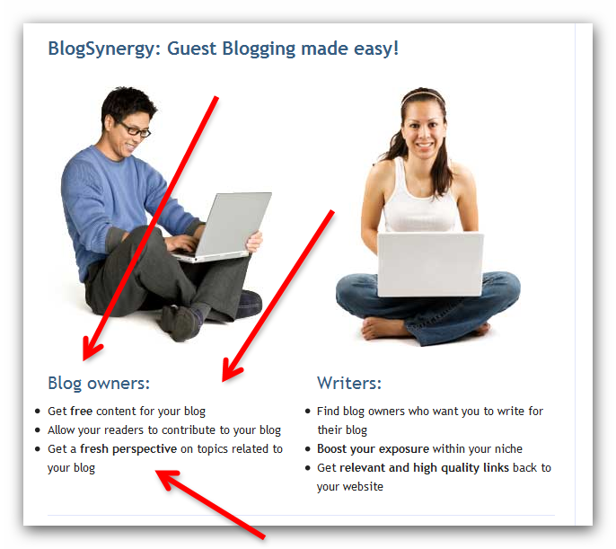

Imagine that!
There is a site that is dedicated to hooking people up who want to write about certain topics to blog owners who need content.
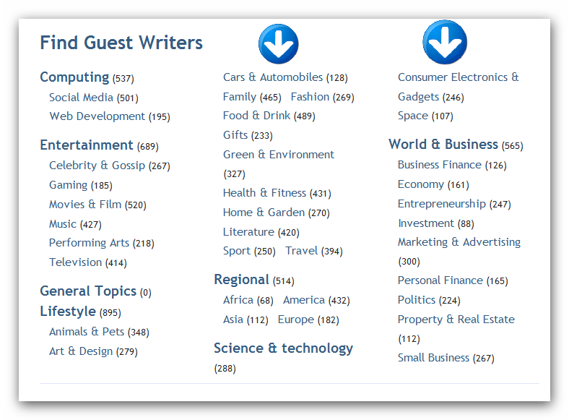

This should be 1 of your first stops to find people who are passionate about the niche you are going after. They are raising their hands and jumping up and down begging people to let them write for their site.
To get started with this site all you have to do is sign up and add your blog to your account. Once that is finished you can start contacting people to write for your site.
http://myblogguest.com



This is an amazing source for getting unique content for your site as well as getting actual authors to write for your site. This site has a slightly different way of offering you content. Hard to argue with a 9K Alexa ranking.
The first thing you will notice is that there is an Article section when you log in with articles that you can add to your site as long as the original author allows it.
The way I suggest that you go about getting unique content written for your site is to actually content members of this site and introduce yourself. Tell them a little about yourself and what type of content/writers you are looking for.

The last way of going about finding authors is to find people who are actively blogging about your specific niche who aren’t getting any traffic at all.
These are people who are actively writing about your niche but the problem that they are having is that they can’t get anyone to read what they are writing!
They will latch onto a lifeline if you will only throw it to them! They want traffic and they want people to read what they write! If you can give them that then they will pump out content like crazy for you.
Here is the key for finding great people to contact to write for your blog. You don’t want to go after the bloggers who have a ton of traffic and already have made a name for themselves. Why would they waste their time writing for your site when they can pump out content to their own audience and put money in their own pocket!
You want to find those people out there who are pumping out content that no one is reading. These people are dying for an audience to hear what they are writing because they are passionate about the niche.
A few different ways to find these blogs is to search a few different sites:
http://technorati.com
http://blogsearch.google.com
Once you find a blog that is in your niche that is being updated with content AND has a low alexa ranking is to contact that author and invite them to write for your site.

Let’s imagine that you were the one who was being given the invite to write for your site, what would you want the person who was asking you to say:
• Be honest! Tell them that you are building a kick ass blog in the xxxxxx niche and you would love for them to become a “contributing author”
• Tell them that you are an Internet Marketer who specializes in “traffic generation”. That is what these people who you are contacting are dying to get!
• Let them know that you will be working to BRAND your authors to build their names in the niche. The more NAME RECOGNITION you can create for them, the better it will look for the site.
Play to their ego and get them on board. Once the ball starts rolling then it will be easier and easier to get people to say yes to you when you ask them.

QUICK TIP
People want to write on blogs that already have traffic. The main indicator of traffic is your Alexa ranking. The lower your Alexa ranking the easier it will be to get people to say yes to your offer of writing for you site.
http://adf.ly
This site will allow you to get 1,000 daily views for $1.

All you have to do is spend $1 a day and watch your Alexa rankings drop like a rock! The lower your Alexa ranking the better your response rate will be getting started.
To make sure that your Alexa ranking is accurate, install the Alexa Statusbar to your site:
http://www.alexa.com/toolbar
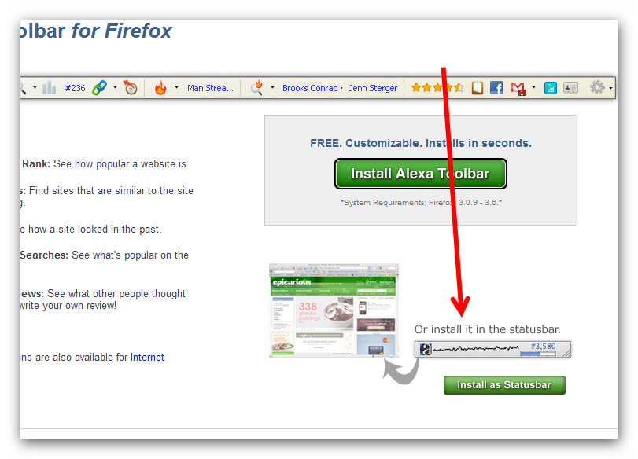

http://ezinearticles.com
This is the last resource that I want to talk about when it comes to getting your level 1 writers. A lot of people who are passionate about their niche turn to ezinearticles to get traffic to their sites. It is a great source of traffic that very few people know how to leverage correctly.
If you do a search for the biggest topics on this site you will find a ton of people who have lots of articles posted to their accounts about a certain niche.
The problem is that their articles have very few views! They just keep pumping out content and get very little traffic in return. That is where you can step in and help them.


This is a lady who is doing better than most authors on Ezinearticles. She is averaging about 400 views per article. If you follow the link at the bottom of her profile it will take you to http://simple-nourished-living.com

Her site is updated often with great content. The problem is that her alexa ranking is 2,472,158. Do you think if you reached out to her that she would be thrilled to guest blog on your fitness site!
Once you can wrap your mind around the fact that people are dying for exposure and you will be doing them a favor for offering them a place to write that people actually read! Do you think that when Martha signed up for Ezinearticles that she would be contacted by someone to guest blog on their site?
Of course she didn’t. She just wanted traffic to her site. She would be thrilled to hear from you. Once you get in the mindset that you are actually helping these people get exposure for their passion the idea of recruiting people to write for your site will become fun and you will have to start turning people away.

LEVEL 2 WRITERS:
To be honest with you, most sites you create will do just fine with just finding authors to write for your site from the resources I have listed above. A blog full of writers who are passionate about the niche that you are in will really shine through on your blog and people will recognize that and your blog will stand out in a crowded field.
Now to take a blog to the next level you will want to find actual professionals as well as people who are academics or real world practitioners of your specific niche. These I am going to cover quickly because most sites will never get to this level. You will have more excellent and passionate writers from the list above that you won’t even need to go this route.
http://helpareporter.com
This site I am only going to cover briefly. It is the most straight forward site that I have ever seen to have professionals emailing you directly to write for your site.
Basically people who are experts in their given niches sign up to be contacted by journalists for interviews and other media related events.
All you have to do is sign up and put together an email that will be sent out and you will have qualified people emailing you with interest in writing for your site.
Now I want to talk about tapping into the greatest resource of experts that absolutely no one is talking about. If you have ever wondered if you could find enough EXPERTS to write for your site then I want to put that to rest right this second.
Local experts are one of the most untapped resource of expert information that no one is tapping into! The good thing is that most people aren’t smart enough to tap into this huge resource of expertise.
If you can show me 1 professional that isn’t looking for more exposure than I will show you 1 professional that is an IDIOT! I know that most people are intimidated when it comes to cold calling.
The reason most people think cold calling is intimidating is that the only reason that you have ever considered doing it is to sell something. I agree, cold calling when you have something to sell can be a little intimidating.
These business owners usually have gatekeepers lined up to keep people who are trying to sell something away from the owner or professional so they can focus on what they do best.
Let’s take this exact situation and completely flip it on its head.
How would the conversation go if you were calling without having anything to sell? What if you were calling from a reputable site in their niche and want to ask them to write for you?
How many people do you think you could get to say yes if had nothing to sell!
Let’s walk through how this would go:
“Hello, may I please speak with Mr. Smith?”
“May I ask who is calling?”
“My name is Josh Jones and I am the Editor in Chief of weightlosspros.com.”
“What is the reason for your call?”
“We hired a public relations firm to find out who our visitors would most like to hear from on our site. They polled people from all over the country and Mr. Smiths name was one of the most popular responses. We are looking for experts in the fitness niche to become contributing authors for our site. I just needed a minute of his time to see if this is something that he would be interested in?”
“Let me get him right away!”

Congratulations. You have just made some ones day. When his wife asks him what happened today, instead of the old “Nothing” response he will now be able to brag that he got called from a major online fitness website to become a contributing author.
It will be like hitting the jackpot for him! Do you think writing for a major online fitness blog will be something that he will tell his friends, family and colleagues about? Of course he will!
To take this a little further you could also get some really cool logos or a seal that he can add to his site so that he can advertise that he is also a contributing author for a major online blog!
Once you start to grasp what it is that I am talking about here the whole idea of creating content will become the last thing that you ever think about. You will literally have an unending source of people who would be thrilled to write for your site.
This perspective will put cold calling into a whole new world. You can literally pick up the phone and make someones whole MONTH!
TRAFFIC:
Hopefully by now you have started to realize that finding people to write for your site is the easiest thing that there is to this whole process.
Traffic is really just as easy when you break it down. You want people who are interested in what you have to say come to your blog and keep coming back.
Every other week there seems to be a new $997 -$1997 course coming out promising to solve your traffic needs. These courses are usually just the same exact information repacked and polished up so that they can have another reason to sell a ton of over priced courses to people chasing a dream. Someone had to say it!
I am not going to bore you with a discussion about SEO, PPC, PPV, Media buying, etc. These are all tactics that work and they work well when they are used correctly.
Since there are already whole courses out there on these topics I am going to hop into some traffic generation tips that will help you get readers right away and build off of that initial traffic.
Facebook is where I always suggest that people start. I don’t mean creating a Facebook app, fan page or even an app. Lets keep it simpler than that.
I know I have talked about http://fiverr.com in the past. The reason for that is that it is an excellent resource for getting people to do work for very, very cheap.
What you want to do is go to http://fiverr.com and search for “facebook”. You will find a ton of people there who are willing to “like” your page to their thousands and thousands of friends. You will find people who are willing to advertise your site on their fanpage as well.
What you want to do is contact these people. Ask them how many of your posts they would be willing to like and post on their facebook page for $5.
Find out exactly how many of your posts they will like. Find out how long they will spread out the likes. Find out how many times they will plug your site on all their accounts.
Anyone who says they will send your “fan page invites” to over 5,000 people has multiple accounts. Unless you are famous, Facebook only allows you to have 5,000 friends. So if they say they have more then make sure that they will like your posts from all their different accounts.
This is a great way to get the word out about your site. To get a like icon added to your site, all you need to do is install a simple plugin: http://wordpress.org/extend/plugins/facebooklikebutton/
That plugin will add a simple FB Like icon on all your posts. It will display the amount of people who have liked your particular post. The higher this number goes, the more traffic you will be getting.
This same technique works for Twitter on http://fiverr.com
There are a ton of people who have lots of followers. How many are real followers and how many are just people who have auto added them is hard to say.
That is why when you contact these people ask them exactly how many posts on your site they will tweet about and how many times they will tweet.
These people don’t want any negative feedback so you will be in the driver’s seat when it comes to making sure that they get the job done. If you can find someone with a lot of good feedback you will be well on your way to some initial traffic.
https://www.mturk.com/mturk/welcome

This site is an untapped gold mine if you know what you are doing . Basically people on this site will do a lot of very simple tasks for pennies!
What you want to do is create a HIT (Human Intelligence Task) asking people to like certain posts on your site. You can direct them to a certain post to build up the likes on that particular post or you can let them choose any post that they like.
For a task like this, you can price it at $0.01 - $0.05 per task. You can also set a limit on the availability of tasks. To start out, use a small budget and play around with pricing.
Let’s say you want 100 people to like a certain post on your site. That means that post will be put on 100 different peoples FaceBook walls and exposed to all their contacts. $0.02 is a good price point for a task like this.
That means for $2 you can get your post liked by real people as well as have it show up on 100 different peoples walls! I am not going to tell you that all these people will have tons of friends. Some will have very few, some will have a lot and some might have all friends that don’t even speak English!
It really doesn’t matter. Just by having that FB Like icon on your post with the #100 by it will give more people a reason to click on it. People don’t want to share something if no one else is. But if they thing that everyone else is sharing the post, they will be more likely to hit that button themselves. Plus, it just makes your posts look that much more popular and your guest bloggers will love it!
Now that we have covered getting some FaceBook and Twitter traffic, lets move onto the reverse side of guest blogging. Guest blogging is also a great way to get traffic to your site as well. Instead of having people write for your site, you will be submitting content for other peoples sites!
Don’t worry, I am not about to suggest that you start writing articles or blog posts yourself. Here is what you do.
Once you start getting people to write for your site, you will be getting a ton of content. Sometimes you will be getting more content then you can post to your own site. That is a good thing!
What you want to do is ask the guest bloggers if you can post their content on some other related blogs in the niche. You can tell them that you are posting it on your colleagues blogs.
The key is that you need to keep their content 100% original. In the resource section of the blog you want to include 2 different links. The 1st link will be back to your blog and the 2nd link will be back to the authors blog. It will go something like this:
“Jane Anderson is a expert contributing author at “YOUR BLOG LINK” where she discusses topic1, topic 2, etc. You can also find Jane Anderson at “Her site or blog”.
This is an excellent way to distribute the authors content to a wide variety of different sources so that they can get more exposure and backlinks while at the same time driving more traffic back to your site.
Content is king in this business. The more you have of it the more you can profit by building your empire. All you have to is search for blogs or sites that allow guest blogging or user content.
The last traffic technique to get rocking is press releases. When you are getting started I would suggest that you stick to free ones unless you have the money to spend on paid press releases.
What you want to do with these press releases is announce every single new author that you get to write for your site. Basically the press release would talk about the author and their qualifications for writing on your site. Then you can add a blurb about your site. Finish it up with a link back to your site as well as a link back to the “Authors page” on your site.

Press releases are like a snowball. The more of them that you release, the more effective each new one will be. The reason for that is the people who use press releases look at a ton of them to pick out which ones are important.
The first time they see 1 of yours and your website name they might not give it the time of day. Then they see another one a few days later. Then a few days later they see another one about your website and the new author that you just got to write for your site.
This will peak their interest and they will take the time to check it out. If a website is constantly getting new people to write for their site then they must be doing something write. A website with traffic is truly a news worthy thing. The majority of webistes out there get 0 traffic!
Once you can afford it, I would suggest you start moving up and start using paid Press Releases. Especially if you get a recognized expert in the field to write for your site. These people will go crazy when they see a press release written just about them!
I just want to add this to this report because I can never seem to fit it into a report. Let’s say that you have someone who you want to write for the site who won’t take your phone calls. This will very rarely happen unless they are a big name.
http://www.hollywoodiscalling.com
Using that link above, you could actually get Lou Ferrigno or Larry Holmes to call them and ask them to write for your site for $20. I don’t know what type of response you would get but I have always wanted to add this to a report and have never got around to it!
There you have it. You now have all the tools that you need to start a killer blog in any niche from scratch and turn it into the go-to blog for your niche.
You should never have a shortage of excellent writers and enough traffic to get the snowball rolling. You will also be creating a business that you can sell in the future since the business won’t be you!

I hope you enjoyed this report and start taking action!

