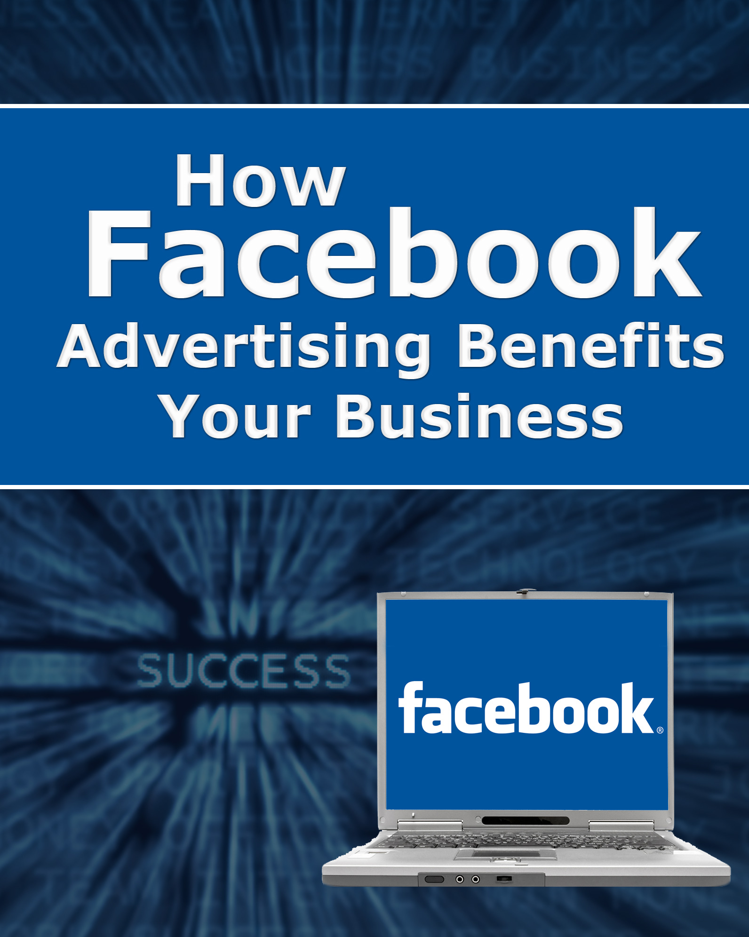

How Facebook Advertising Benefits your Business

You’ve been working hard to introduce your business to as many potential target customers as possible – the ones who will find your products irresistible, and eagerly spend money. You’ve done it through SEO, social networking, press releases, article marketing and perhaps even a pay-per-click campaign like Google AdWords. In short, you’ve used all the traditional (and not so traditional) ways that help online business catch on like wildfire.

But have you considered Facebook advertising yet? If not, you may not be aware of this comparatively new source of targeted customers – the sort who you may not be able to reach by traditional means.

Exactly what is Facebook advertising, and why should you consider it?

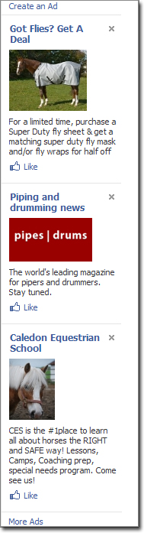
You’ve seen them yourself, most likely… those ads running down the right-hand side of your Facebook pages, most of them about interests you particularly enjoy.

You are not seeing the same ads as everyone else accessing Facebook at that moment. These ones are specifically targeted to data Facebook has gleaned from your preferences and other sources.

Facebook ads are simple but powerful. Each one consists of a title, text block and graphic or photo of your choice – all within a 110px X 80px “box”, to fit that vertical, right-hand Facebook sidebar.

If you think of them as a cross between a Twitter tweet and a banner ad, you’ve just about got the picture!

And yes – they absolutely can advertise your:

- Product
- Services
- Contest
- Cause
- Links
- Photos
- Videos
- Business USP
- Business Event

As well as integrating:

- Your offline promotions with your online
- Real-time information for your “fansumers”
Facebook Advertising Benefits

SEO vs. Social Trends – Facebook’s biggest benefit is its most obvious. It operates through social networking and trending rather than pure SEO – the hottest trend of this brand new decade. It allows readers to see your ads on their mobile phones – and mobile devices now outnumber personal computers, 4 to 1!

It is also cheaper than Google AdWords, and while the latter is still a wonderful way to kick-start a campaign, AdWords can be risky for newer marketers, as costs per click can skyrocket faster than your sales.

Will it replace AdWords completely? That shouldn’t be your goal! Plan further down the line to do what the big boys and girls do: Kick-start each campaign with well-optimized and researched AdWords.

Facebook vs. Adwords Costs – But whether you use Adwords (SEO based) or Facebook ads (social networking based), Facebook ads nowadays are a “must” – particularly with the not-so-subtle switch over to mobile devices! But it’s great for beginning marketers because at the moment, it’s significantly less expensive to advertise on Facebook than with PPC!

Graphics Capability – It’s other biggest benefit is that you can introduce a graphic element or photo into what is basically just a small text ad! Since Facebook is “tuned” to graphic elements, and interest has been shown to peak when graphics are displayed, it wins hands-down over AdWords tired, irritating banner ads (traditionally low converters for over a decade).

(You could simplify it like this: Want a text ad only? – Use AdWords. Plan to use a graphic? – Use Facebook Ads.)

Text Capability – You have 75 words to say what you want to say in Google AdWords (that’s less than half a tweet!) Facebook ads not only allows you a 25-character headline, but 135 words of body text, too. (That’s over double Google AdWords’ capacity – but note; spaces count.)

Does SEO Still Apply?

You betcha! In fact, it’s absolutely crucial to the success of your Facebook Ad!

Remember when we talked about Facebook Ads geared to your specific hobbies, tastes, preferences and interests appearing down the right-hand side of your Facebook page? You’ll notice that:

- Some really don’t appeal to you
- A small percentage make you click on them right away
- … and yet a third group appeals to you, but it may take you days of repeated exposure, seeing the same ad many times, before you finally give up and click through.

You want your ad to be in the latter 2 categories. And you achieve that through solid, well-researched long-tailed keywords (combined with your irresistible, curiosity-arousing 25 character headline and 135 character body text).

Get those elements right, and you’ll have an ad that bypasses casual searchers (how many right-hand-side Google search page paid ads do you ever click on, compared to Facebook Ads?) and zeros in on a 75% pre-sold, pre-qualified market.

Who Is It For?

Some people will tell you that Facebook Ads don’t work for business purposes, but that’s simply not so. It should speak volumes and give you a big, fat clue about its potential when you realize that major companies are taking full advantage of Facebook Ads, in creative ways.

For example, according to Facebook’s own Marketing Solutions page…
- Honda recently used Facebook Ads to keep consumers updated (and do serious damage control) after its recent spate of shocking recalls.
- Budweiser encouraged social interactivity with its customers when it invited them to select which commercials to show during televised sports games.
- Guitar Hero became the first online video game to reach 1,000,000 fans on Facebook
Even Coca-Cola jumped on the bandwagon, selling “virtual bottles of coke” and promising to donate $1.00 for every virtual bottle sent to their favorite cause.

These 4 examples alone show you the sort of creativity you can employ (and flexibility you can take advantage of) when creating your Facebook Advertising campaign!

“Fansumers”

If you’ve been wondering what a “fansumer” is, it’s yet another social phenomenon you can use to your advantage.

According to Forrester Research, a “fansumer” is simply a consumer who has “become a fan” of a brand on Facebook.

This brings us back to Facebook Ads’ third biggest advantage… interactivity.

It’s a proven maxim: Get people to engage as a participant, rather than as a spectator, and their stake in what they’re engaging in becomes personal and more positive. Use an app or a product and click the little “become a fan” text link on your Facebook page, and you are not only contributing to its statistical popularity, but personally endorsing it!

This can help 2 particular types of “product” in particular…

- Apps (applications such as Zynga’s “Farmville” game)
- Brands

Allowing people to become Facebook fans should be a definite part of your branding campaign… and as for Farmville’s meteoric rise, it is legendary. One only has to take a glimpse at its U.S. Alexa rank of 370 to see how powerful this can be.

Alexa summarizes this popular app game thus: “… farmville.com is visited more frequently by females who are in the age range18-24, received some college education and browse this site from home.”

This is right in line with Facebook’s “18-34 female” broad demographic – but the truth is, you can certainly reach other target customers in different demographics, if you take a close look at Farmville’s stats from Quantcast.com:

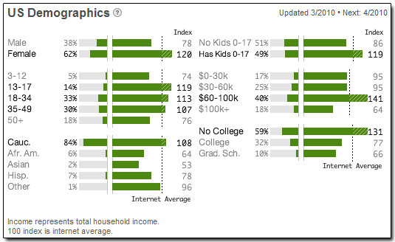

Keeping in mind that a less broad and more specific demographic is likely to be yours (unless you create a truly buzzworthy product like Farmville) you can certainly play to small niche Facebook markets.

A good rule of thumb is to make sure the niche customer you wish to reach actually does operate via social networking at least as much as – if not more than – through standard PC use and Google searches.

You can also target specific geographic areas, using Facebook Ads (by country, state or province, town or city).

And remember, when someone brands him or herself as your fan (or “fansumer”), they are letting you know they are ripe for your offerings.

Why Profile Pages are Your Friends!

The main reason you can target so specifically, in spite of Facebook itself have a broad, generic demographic, can be attributed to profile pages.

Think about it: When you filled out your profile page, you were prompted to share your:

- Hobbies and interests
- Career and work information
- School, college or university
- Tastes in music, books and movies
- Personal and contact information (date of birth, marital status, etc.)
- City and state

And as much extra information as you chose to share.

Among the things you share you can bet people can find great long-tailed keywords! These are what you should use when creating your Facebook Ads – targeted specifically to your ideal customer, of course. Use your keyword in your headline at the very least – and again in the text (always providing it feels totally natural: Remember, Facebook puts “social” before “SEO”).

The Mechanics

In addition to the creative side of your Facebook Ads, there are other actions you can choose to take. You can:

- Pay per click (PPC)… or per impression (CPM)
- Track your Ad’s progress in “real time”
- Edit and tweak your ads, for your best results

Best of all, Facebook Ads are easy to set up, with a step-by-step process that guides you clearly through creation and all your options.

Facebook is quietly becoming the newest 2010 trend in online advertising – especially for those on a budget – as of this writing. Even if you don’t think it’s right for your business, you are to be applauded for taking the time to at least learn more about it!

